Answer Key to Geography Study Guide

Population Map

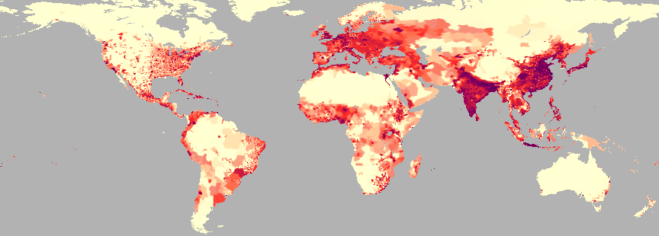

1. Using the map above, write three facts about the world population.
India and Southeast Asia are very densely populated.
The areas near water are the most heavily populated.
Europe is another continent that is heavily populated.

2. List ways in which people adapt to their environment.
People adapt to their environment by cutting down forests to make farms and grow crops.
They might use irrigation to water their crops. People adapt to climates by wearing warm or
cool clothes or by using heating and air conditioning. If they live in area where there are
frequent storms, they may have a tornado shelter.

3. What are some ways people change/modify their environment.
People clear land for building roads and houses or factories.

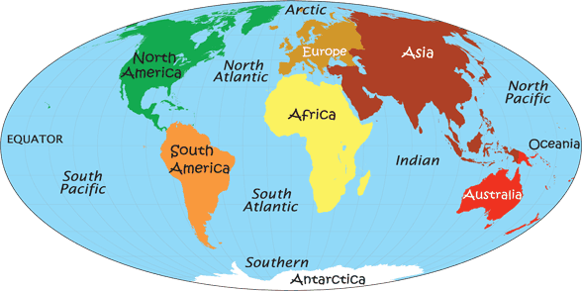

4. What continents are completely surrounded by water?
Australia and Antarctica are completely surrounded by water.

5. How would you describe Europe’s location in relation to Asia?
Europe is located west of Asia.

6. Explain the difference between absolute and relative location.
Absolute location is the exact location of a place. Relative location is where something is
located relative to another place.

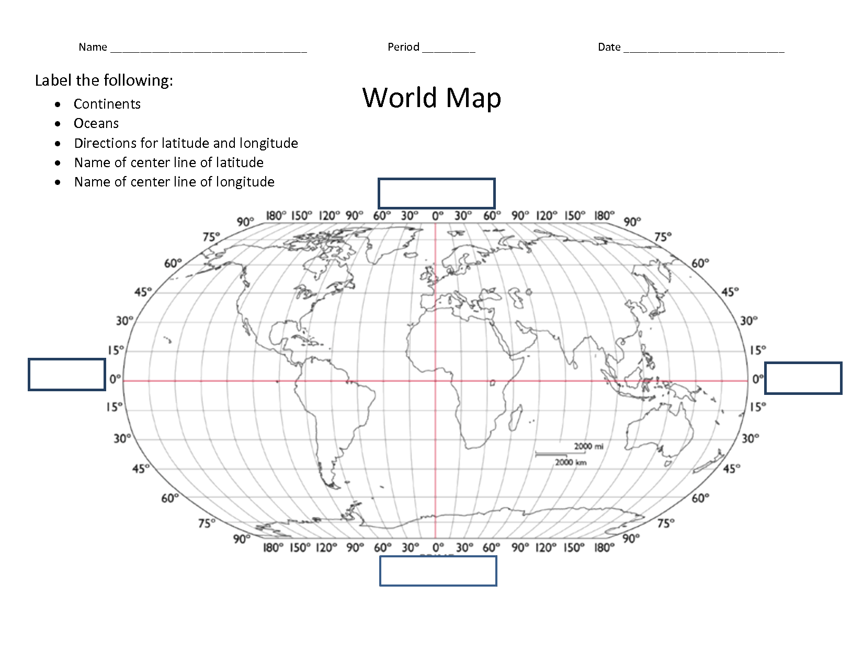

7. Using the map above, name the continent that can be found at 15 degrees S latitude and 60 degrees W longitude.
South America

8. Name the continent that can be found at 60 degrees N latitude and 150 degrees E longitude.
Asia

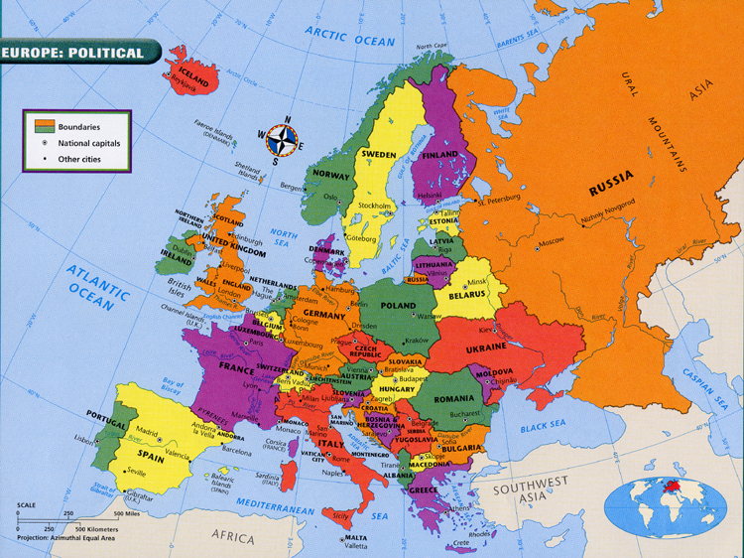

9. What are some European countries that border the Baltic Sea?
Poland, Latvia, Lithuania, and Estonia

10. Define peninsula.
A peninsula is a piece of land that is bordered by water on three sides but connected to the
Mainland. Florida is an example of a peninsula.

11. Define island.
An island is a piece of land completely surrounded by water.

